# 7/10/2017:

Deciding on an idea Pros and Cons of the top two ideas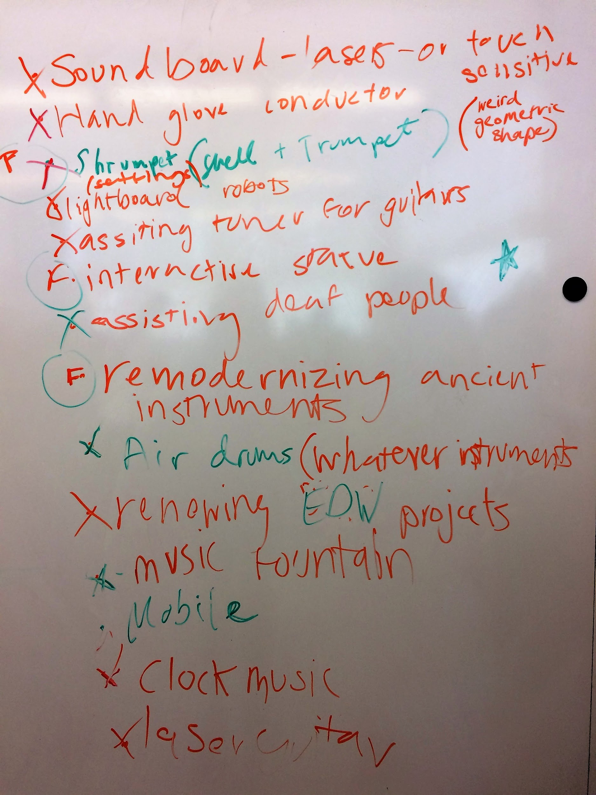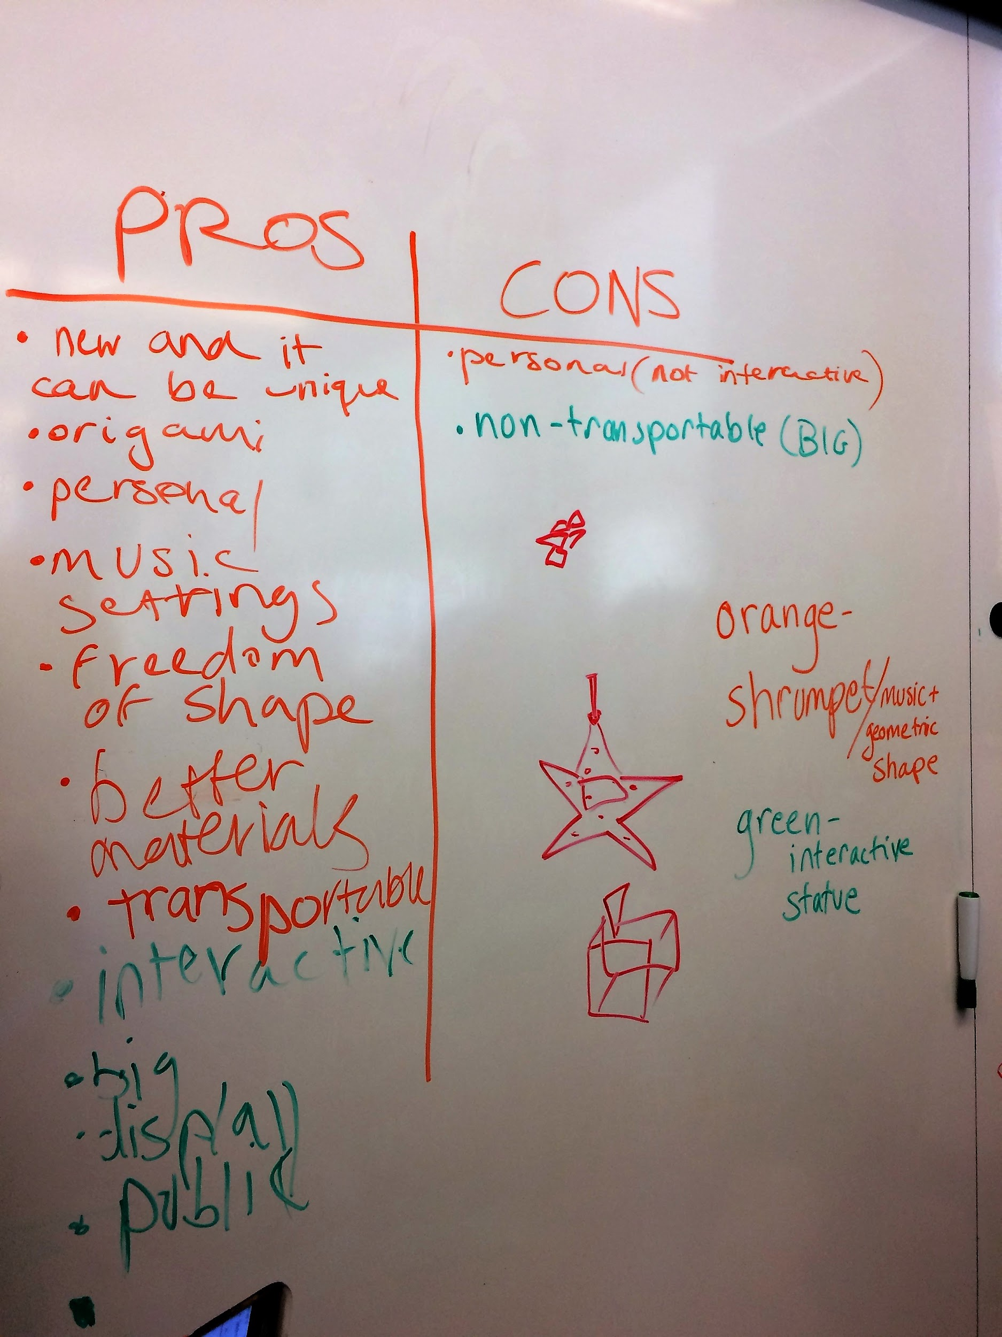

**Different Ideas**

-laser tunnel/laser box:

Layers of lasers, each one playing notes from different types of instruments.

-Light board:

Songs are programmed by path following robots.

-Constructable origami device:

It changes the sound that is played based on how Intensely you blow into it.

-Interactive statue:

Based on the area of the statue that is touched a sound byte will play and the area will light up.

-Guitar with touchpads:

Based on where you touch a sound is played in correspondence to where the string would be

**MISSION STATEMENT**

We want to create a project that enhances musical and interactive experiences through the combination of visual arts and technology

# 7/11/2017:

**Sliding Laser tunnel V1**

-Wooden Circle Frame (laser cut?)

-Attach a sleeve outside (pretty designs) (cardstock?)

-6 laser per ring

-Circle hinges to spin out the rings

-An extra ring is added to hold the arduino for the system.

**Instruments used (Sliding Laser Tunnel V1)**

-String:

Guitar

Base

Violen

-Brass:

-Production:

-Woodwind:

**Prototyping V1 Details**

-Cardboard

-1 laser as a test

**End Goals For The Project/ Values**

* Easy to use and move around
* Pleasing to use
* All Ages
* Individual Parts?
* Easy to mass produce
* Multiplayer
* ~~Detachable~~
* Play notes individually
* Aesthetically pleasing
* New from anything created
* Interactive
* Pleasant note steps

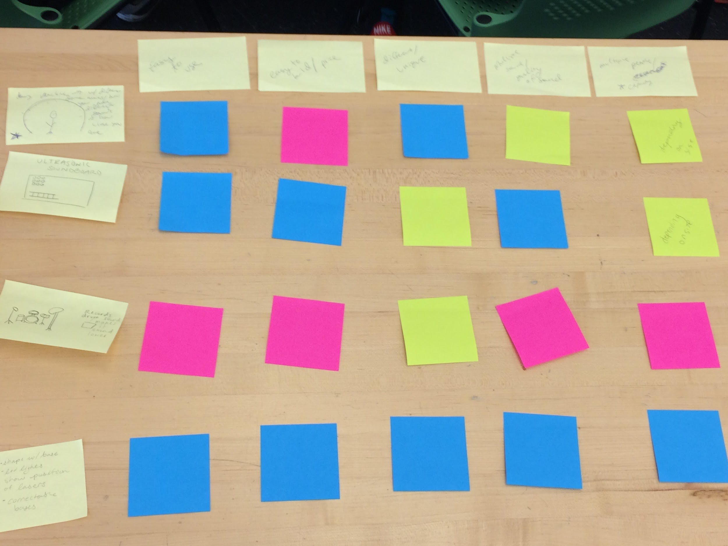

Design Criteria Matrix (Thanks Helen!!!)

Pink=Bad

Green/Yellow= Medium

Blue= Good

We created ideas and then ranked them with our values which were (left to right) easy to use, easy to build, unique, different notes/ quality of sound and can be used by multiple people.

**Sonic Arch**

* Based on how far away you are from the ultrasonic sensors

mounted in the arch a sound byte will pay at varying intensity.

* The measurements of the design is based on the height and

Wingspan of Yveder as he is an extreme when it comes to

human size, if he can fit than almost anybody can.

* Ultrasonic sensors will be attached around the arch.

**Why We Changed Our Design**

Complications with

-using hinges VS making separate rings

-shape of the wood with lasers

-type of sensor we will use

Just tired about the idea in general (low moral towards the tunnel idea)

# 7/12/2017:

Height: 7ft

Width: 7ft

Depth: 2in

**Prototyping (actually now) V1**

-Use table for testing 2 ultrasonic sensors

-Use sample code from Yveder’s old project

-Using rechargeable batteries for power

-Cardboard for positioning sensors, arduino, speakers

**How to assemble the music shield**

https://learn.adafruit.com/adafruit-music-maker-shield-vs1053-mp3-wav-wave-ogg-vorbis-player/assembly

**Part of Code (testing ultrasonic sensor)**

const int trig = 1;

const int echo = 0;

int duration;

int distance;

void setup() {

Serial.begin(9600);

pinMode(trig,OUTPUT);

pinMode(echo,INPUT);

}

void loop() {

// put your main code here, to run repeatedly:

//send a short low pulse to ensure a clean

digitalWrite(trig,LOW);

delayMicroseconds(2);

digitalWrite(trig,HIGH);

delayMicroseconds(10);

digitalWrite(trig,LOW);

duration = pulseIn(echo, HIGH);

//Sound travels at 340m/s so based on how long the ping you sent out took the be received the distance between your device and the object the sound bounced of is calculated in cm.

distance = duration*0.034/2;

Serial.print(distance);

}

Information on using arduinos, ultrasonic, and music: http://forum.arduino.cc/index.php?topic=276605.0

**Today’s Accomplishments**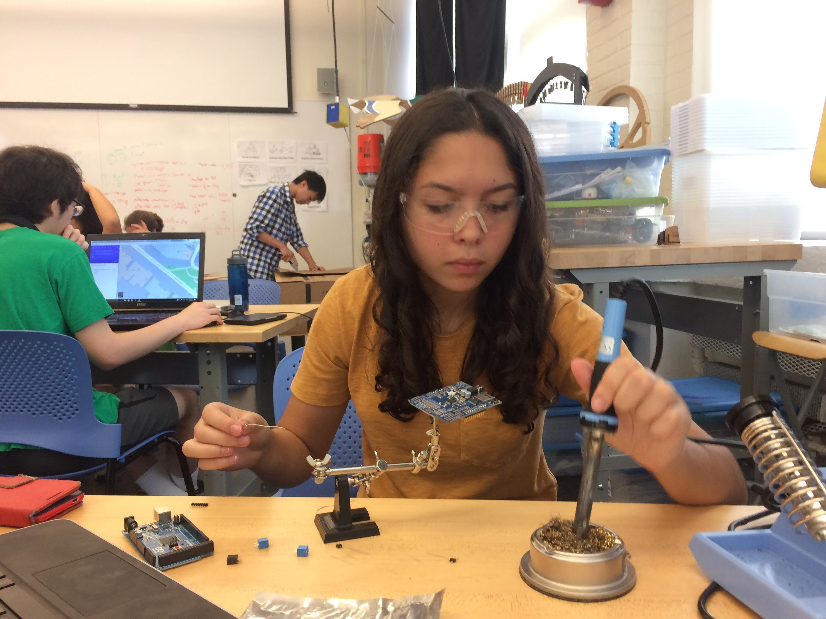

-Finished soldering the music shield

-We need to make sure the “ground” pin and the 5V pin are not covered (need for ultrasonic sensors)

-Used the ground and 5V pins on the actual music shield

-Finished setting up prototype

-Using legs of the table

-In progress with learning (and understanding) the coding for the ultrasonic sensors and the music shield

SPECIAL THANKS TO CHRIS FOR HELPING WITH SOLDERING ISSUES TODAY!!!!!!!!!!

# 7/13/2017

**Prototyping Day 2:**

-Frequency and tone use in code to simplify it

-<https://en.wikipedia.org/wiki/Piano_key_frequencies>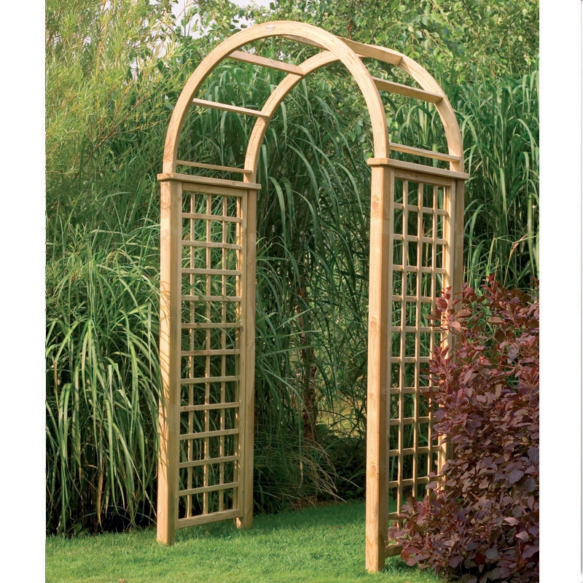

-Archway Ideas

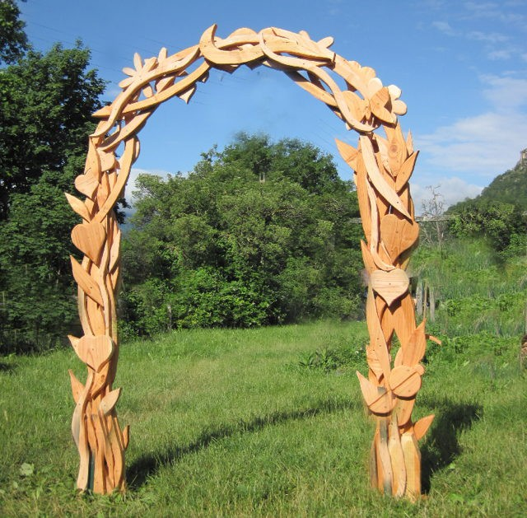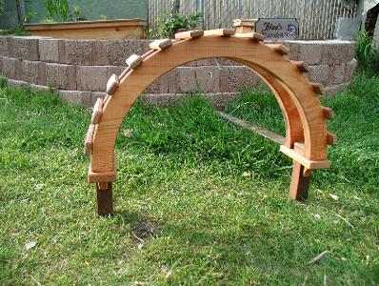

**Programing update:**

**-**We might not end up using the Adafruit music shield as we could not get the Arduino

IDE to recognize the directory for it.

-We might end up using the same music shield that the laser harp uses as it so far seems

easier to use,

-We got the Arduino to play different tones based on how far away you are from the sensor

**Design/Building Update**

-Got the measurements

-2’ by 4’ stands

-3.5’ by 3.5’ half arch pieces

-2” by 2” wood pieces in between the arches

-Done cutting out one arch (two half arch pieces)

-Learned how to use the bandsaw and sanding machine

# 7/14/2017

**Programing update:**

-We swapped out the Adafruit mp3 shield for a spark fun Musical instrument shield.

-We programmed the shield to play in conjunction with the ultrasonic sensor.

-For now we’ve limited the range of the sensor to 50 cm max.

-We eliminated the problem of negative values showing up as a value for the distance variable.

-We programed the shield to play three tones based on if your less than 10 ,then less then 30, or less than 50 cm.

**Design/Building Update**

-Created the bases for the archway

-Cut off 1.5 ft off the original base because the arch was too tall

# 7/18/17

**Design/Building Update**

-Connect arches and post together using nuts and bolts

-Cut off a part of the arch because it was unbalanced

-Started the mount for the sensors

-Tested with three sensors on multiple people with different heights

**Programming update**

-We got all 7 ultrasonic sensors to work.

-We discovered how to make the ultrasonic sensors play different instruments.

# 7/19/17

**Design/Building Update**

-Finished the mounts for the sensors (7)

-Built the box for the arduino and breadboard

-Use hinges to open the top off

-Have one side open for wiring

# 7/20/17

**Design/Building Update**

-Screwed in the box for the arduino and the breadboard

-Screwed in the mounts for the sensors

-Made sure the sensors fit into the mounts. If one didn’t fit, then we filed or hacksawed the wood to make more space for the sensors.

**Programming update**

**-**We mounted the ultrasonic sensors using ribbon cables

-We than cut the wiring for the arch in half and built a connector to connect them back up.

**FOCUS GROUPS:**

Instruments used to test:

2

8

10-xylophone/gloshtiegno

46-bass thingy

23-organ

124

116

questions to ask:

what do you like?

what do u not like?

melodic, percussion, or electronic instruments?

which one do you like the best?(at the end)

group:

2—little boring,dull sounds

8—likes first one better, sounds electronic,

10—likes a lot, melodic

favorites: caitlyn, 2 and 10, and 8

comments:don’t know what to do, major key, a more happier sound, this is lots of fun

Brandon, jessica, tony:

10--no major notes,

46--noise not music?

124--????

Likes electronic?

9--pleasant, likes this one

Ed

43--

Improve sound aspect of it, add surround sound

10--